Agenda of Today’s Meeting (11th-February’25)

1. Flow of License creation & validation:
- The SPEC Team will demonstrate the understood flow of license generation from the License Application and its validation in the Client Application.
- Following the demonstration, you are welcome to share your feedback or inform us of any required changes to the license file or the overall license process flow.
The SPEC Team has demonstrated the entire flow and prepared the License File. Additionally, Bala has approved it and suggested encrypting the highlighted plain text in the below file to enhance security. The file extension will remain “.lic” only:
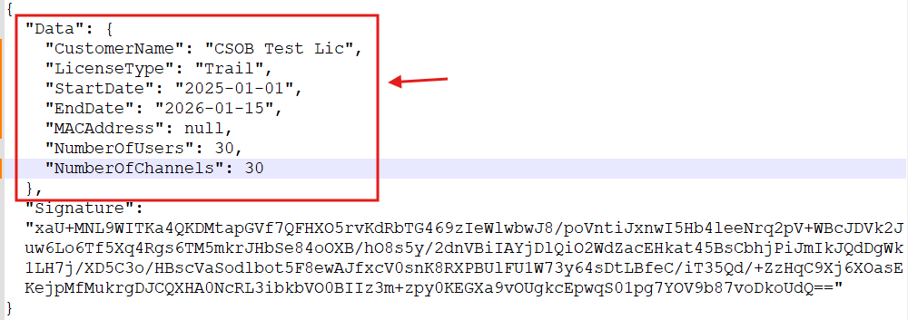
2. Camera Management:
- What is the Purpose of Each Field on the Camera Creation Form, and Where Will It Be Utilized? Please Elaborate! That will be helpful for me to mention things in the SRS accordingly.
- Kindly Provide the API names / endpoints:
- Which needs to be utilized on this page to validate the information?
- Which are required to fetch associated camera information from the AI Box?

3. Associated API Names for Dashboard Widgets
- We need list of associated APIs for following widgets:
- Camera Widget
- Site Widget
- People Widget
- Retail Widget
- Vehicle Widget
- Factory Widget
4. Floor Plan Management:
- What is the purpose of integrating the map within the floor plan? Could you please provide more clarity on your specific expectations?
- Are there any special validation rules or data instructions to be considered while creating the floor plan?
- Are there any restrictions on image size or format that we should be aware of? - 10MB
5. Zone Management:
- Based on the initial discussions with Jigar and Mitesh, we have identified the following mandatory fields for creating a Zone on any Floor Plan:
- Name of the Zone*: A unique identifier for the zone.
- Max Occupancy*: The maximum number of people or vehicles allowed in the zone.
- People Occupancy*: The max number of people allowed in the zone.
- Vehicle Occupancy*: The max number of vehicles allowed in the zone.
- Reset At*: A time value indicating when the occupancy counts resets.
- All fields are mandatory.
- Please let us know in case any suggestions/changes regarding the above fields.
- Additionally, we would appreciate brief insights on each field and its specific utilization within the application to enhance clarity.
6. Add cameras on zones:
- We would also like to understand the logic for displaying cameras while adding them to a Zone:
- What criteria determine which cameras should be displayed or excluded?
- Is there a specific limit or selection rule for associating cameras with a Zone? – No Limit

10. Camera rotation:
- We need more clarity on your expectations regarding the camera icon functionality.
- Currently, we have assumed that the camera icon should rotate 360 degrees when clicked, instead of requiring the user to move a slider from left to right. Please confirm if this approach aligns with your requirements.
- Example:
